Year 11 French Curriculum Map
 | Autumn Term | Spring Term | Summer Term
Unit Length | 15 weeks | 12 weeks | 13 weeks
Links to the National curriculum/Assessment Objectives | AO1 Listening  AO2 Speaking  AO3 Reading & Translation  AO4 Writing & Translation | AO1 Listening  AO2 Speaking  AO3 Reading & Translation  AO4 Writing & Translation | AO1 Listening  AO2 Speaking  AO3 Reading & Translation  AO4 Writing & Translation
Description of the topic and key learning outcomes (key knowledge and understanding) | Module 8: Un oeil sur le monde  Theme: International, global  The topics areas covered are:  - Weather & natural disasters  - Protecting the environment  - Ethical shopping  - Volunteering  - Big events  Content finished by October half term. Mock Speaking and Listening, Reading, Writing prep till Christmas. | Revision  The topic areas covered are:  - Who am I?  - Leisure  - Daily routine & festivals  - Home town & local area  - Holidays  - School  - Work  - The Environment | Final GCSE Exams
Related Concepts (that are revisited) | General environmental awareness / Using cognates & near cognates to deduce meaning / Using modal verbs / Asking questions / Giving Opinions/PALMO/ BORDUM and Star words. | Asking questions / Giving Opinions/PALMO/ BORDUM and Star words. | Asking questions / Giving Opinions/PALMO/ BORDUM and Star words.
Skills being taught | Listening, Speaking, Reading, Writing and Translation | Listening, Speaking, Reading, Writing and Translation | Listening, Speaking, Reading, Writing and Translation
Milestone assessments | AC1: Progress Test. Listening, Reading, Translation all themes to date.  AC2: Mock Listening, Reading, Writing | AC3: Mock Speaking (including AC2 mock mark)  AC4: Mock 2 (including AC3 mock speaking mark) | Speaking Exam: Teacher assessed  May 2021: Listening and Reading Papers  May/June 2021: Writing Paper
Wider reading | www.duolingo.com  www.memrise.com  www.gojimo.com
Literacy programme | - Simple future tense  - on doit/on peut + infinitive  - The passive  - Emphatic pronouns  - Three time frames | - Exam strategies. PONDS, Star Words  - (Near) cognates, false friends  - Listening & reading for gist and for detail  - You see it, you say it.  - PALMO, BORDUM  - Uncommon structures | - Exam strategies. PONDS, Star Words  - (Near) cognates, false friends  - Listening & reading for gist and for detail  - You see it, you say it.  - PALMO, BORDUM  - Uncommon structures
Homework / Independent Learning Tasks | 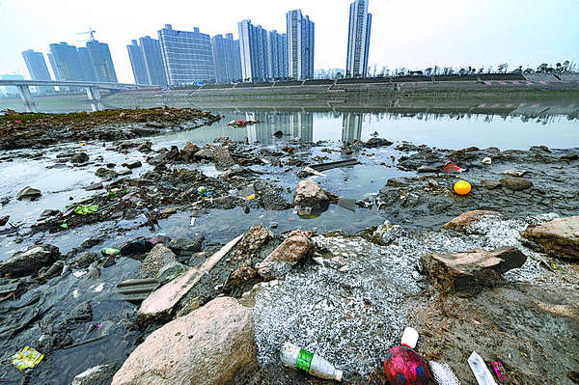  - Write 20-30 words to describe the photo above.  - Write 40-50 words about charity work (what you do to help others, a recent charity activity, why it's important to help others and future charity plans.  - Write 80-90 words about protecting the environment (what you do/don't do, what you or others should do, what you will do in the future). | Work through your:  - GCSE Photo-card booklet  - GCSE Writing booklet  Revise vocabulary and structures using the websites above. | Work through your:  - GCSE Photo-card booklet  - GCSE Writing booklet  Revise vocabulary and structures using the websites above.
Oak Academy Links to support Remote Learning | Key Stage 4, French  Unit: Global Issues  Lessons 1-16  https:// .../global-issues-0d1a | Revision of tenses  Year 9 Unit 1, lesson 10  https:// ...er-verbs  Year 9 Unit 3, lessons 1-12  https:// .../year-9-unit-3-d71f  Year 9 Unit 4, lessons 1-10  https:// .../year-9-unit-4-8c4f  Year 9 Unit 5, lessons 1-8  https:// .../year-9-unit-5-5d78

